Book of Remembrance

Entries in memory of those members who passed away since the inception of the website all entries are placed alphabetically in the month and year of their passing.

Family and friends are encouraged to submit short passages which will be added to the entry.

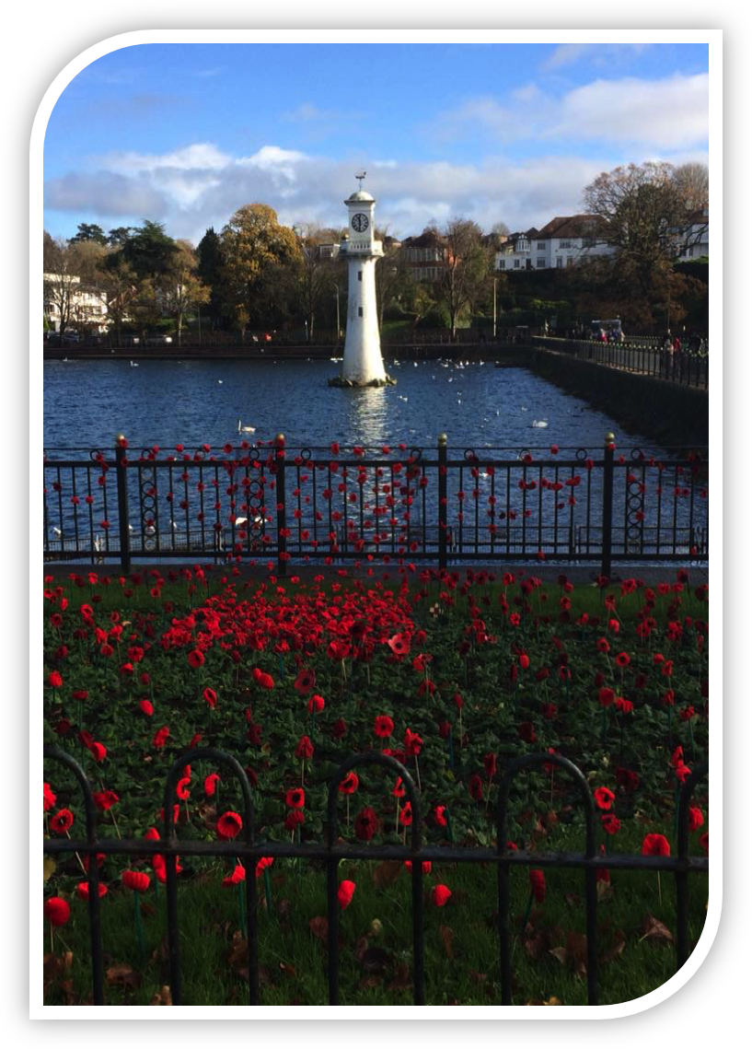

Image is of the ‘Knitted Poppy Field’ at Roath Park Lake in November 2017

Courtesy Mrs. Christine Bryant

"The Poppy"

Birdsong silent, commended to die,
knee deep in mud, their bodies piled high.
brave young heroes, who would not yield,
blood red it flowed in Flanders Field.

No more rifle or gun did they wield
their resting place now, a far foreign field,
Heartbroken loved ones, never to see,
they gave their lives, it was God's decree.

Bleak and barren, where nothing would grow,
except for the poppy, row upon row.
Heroes they fell, their fate always sealed,
Blood red the colour of Flanders Field.

The poppy, resilient, delicate and strong,
a reminder of brave men, lost in the throng.
Remembrance Sunday, we honour the brave,
Flanders Field poppies, adorning their graves.

  - Arthur Cole....2016....All Copyright Reserved(77)

A - D A - D

2014

Bowyer Peter March 2014

Davies Gerald (Gerry) April 2014

Blunsdon Paul May 2014

Davies Tim July 2014

Cole Jeff September 2014

Denley Peter December 2014

Abraham Joan December 2014

2015

Bevan Glyn June 2015

Collins Joyce November 2015

Davies Royston Keith November 2015

Brook Margaret Jean November 2015

2016

Beach Mike February 2016

Arthur Tom March 2016

Coombs Anthony Emmerson March 2016

Dibble Beryl April 2016

Carroll Robert (Bob) May 2016

Bancroft Robert (Bobby) June 2016

Dibble Sidney Jack August 2016

Davey Sylvia November 2016

A’Court Gordon December 2016

2017

Conway Stephen Paul January 2017

Davey Graham March 2017

Aslett Bill April 2017

Cornish Doug April 2017

Brooks Ronald Frederick June 2017

Cotterall John August 2017

2018

Cotterell Steve February 2018

Baker Zena March 2018

Allinson David September 2018

Coombs Iris October 2018

Cotterell Shirley December 2018

2019

Culliford James Henry June 2019

Collison Anthony July 2019

Abraham Derek November 2019

2020

Corcoran Brian March 2020

Ashley Brian. April 2020

Clarke Ritchie. June 2020

Cotter Stuart. June 2020

Brown Mike. August 2020

Dann. Colin August 2020

E - I E - I

2014

Germon Malcolm December 2013

Finlay Alex January 2014

Genner Brian February 2014

Goddard Bernard February 2014

Ellis John (Jake) September 2014

2015

Evans Colin January 2015

Evans Robert February 2015

Edwards Jean December 2015

2016

Griffiths John April 2016

Harris Jack July 2016

Hooper Sam December 2016

2017

Hunter John January 2017

Holder Beryl February 2017

Evans – Williams Maureen June 2017

Hocking James Henry July 2017

Gould Jeff July 2017

Fryzer Stephen September 2017

2018

Edgell Joan August 2018

Ford Gwendoline August 2018

Green Jim September 2018

Flynn Brian October 2018

Holley Robert November 2018

Gibbins Alan December 2018

2019

Hobbs Andrew January 2019

Hodges Stephen February 2019

Gunn Ray March 2019

Fox Margaret April 2019

Hooper Brian June 2019

2020

Peggy Eklund. January 2020

Hastie. Margaret April 2020

Ford. Doug May 2020

Eynon. Jim August 2020

Hockeridge. Thelma. October 2020

J - N J - N

2014

Maccormack Mary Joanna February 2014

Lewis Graham September 2014

Lemperier Trevor December 2014

Lewis Ken December 2014

2015

McMillan Andrew January 2015

Moffat Bob April 2015

Morgan Dorothy July 2015

Maxwell Robert Keith August 2015

Jones Katherine Ann November 2015

Lloyd Beryl November 2015

2016

Kirby Frank September 2016

2017

Lee Madeline January 2017

Malyn Judith April 2017

Mortimer Ken July 2017

Langan Jane September 2017

Loe Harry Julian September 2017

2018

Macdonald Gerry February 2018

Moore Deri September 2018

2019

Kiff Ryland February 2019

Mordecai Clive September 2019

2020

Lee Bob April 2020

Morgan. William (Billy) April 2020

O - S O - S

2014

Snelling Alma January 2014

Shilton Douglas January 2014

Pocket Glyn (M.B.E.) June 2014

Sadler Kevin Michael July 2014

2015

Simons Cliff February 2015

Smith Cliff May 2015

Stow Sylvia June 2015

Shepherd Louise October 2015

Phillips Stephen Martyn November 2015

2016

Rees Jeff (Gypsy) January 2016

Stow Gordon January 2016

Rees Elvet April 2016

Patterson Chris June 2016

Root Michael December 2016

2017

Richards Bernard May 2017

Palmer John June 2017

Sullivan Kevin July 2017

Rowlands William November 2017

2018

Summers Christopher January 2018

Pearce Derek July 2018

Probert Clive October 2019

Parsons Doreen November 2018

2019

Smith Robert (Big Bob) February 2019

Rowlands Malcolm Colin October 2019

Smith Christine December 2019

2020

Salvidge. Cyril March 2020

Symes. Ron April 2020

Parker. Alistair December 2020

T - V T - V

2014

Taylor Steve December 2014

Tooby Alan December 2014

Thomas Neil December 2014

2016

Trigg Peter February 2016

Trigg Shiela April 2016

2017

Thomas Peter Spence July 2017

2018

Ursell Bernard October 2018

2019

Tagg Thelma February 2019

Tumelty John (Jack) M.M. July 2019

Vincent Malcolm December 2019

2020

Totman Roger April 2020

Toogood. Graham April 2020

W - Z W - Z

2014

Walters Malcolm (Mac) May 2014

2015

Williams Alan July 2015

2017

Watts Desmond November 2017

2018

Woods Ron February 2018

Walsh Michael March 2018

Williams Marian June 2018

Woodward David July 2018

Webster Len August 2018

Woodings Charles November 2018

Watson Bob December 2018

2019

Wiltshire Margaret November 2019

2020

Williams Roger S. January 2020

Williams. Betty January 2020

Watham. Mary. February 2020

Webber Josephine. February 2020

Williams. Maureen May 2020

Westacott. Ivy. September 2020

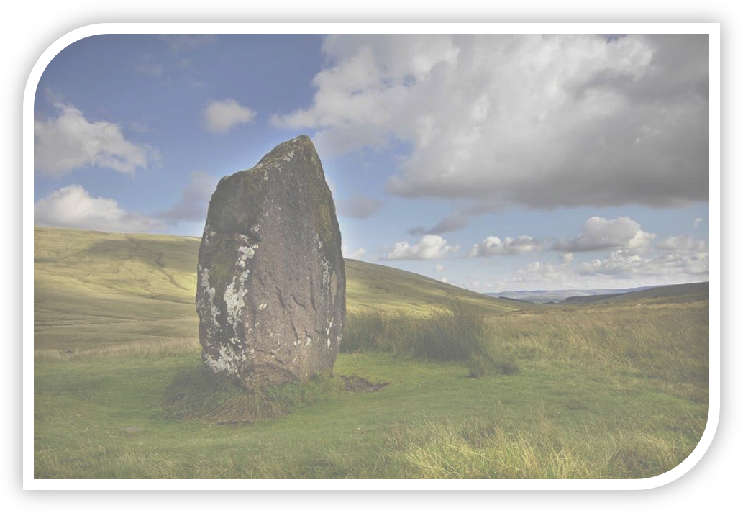

Photograph Courtesy of Carl Ryan, is of "Maen Llia" a large standing stone situated on the moorland of the Brecon Beacons. The stone is surrounded by legend and myth, with the Druids being involved somewhere along the line. They were learned and religious individuals, however there is very little written about them"

"Maen Llia"

Standing for centuries, an immovable giant,
Druids her masters, spiritual or science.
A Shamanic religion, shrouded in mystery,
A monolith diamond, confined now to history

High on the Beacons, so vibrant she stands,
Grey, weather worn, at the Druids' command.
Surrounded by nature, winds strong and fast,
Storm clouds rolling, a dark shadow cast.

To serve what purpose, religious or burial,
These questions posed, since time immemorial.
No written accounts, all secrets concealed,
Her legacy, now folklore, if one's to believe.

With evening suns dimming, long shadows are cast,
a thirst that needs quenching, resurrecting the past.
Slowly moving across moorland, her secrets untold,
Druids' spirits abounding, to them she beholds.

Arthur Cole....2017....All Copyright Reserved(105)

